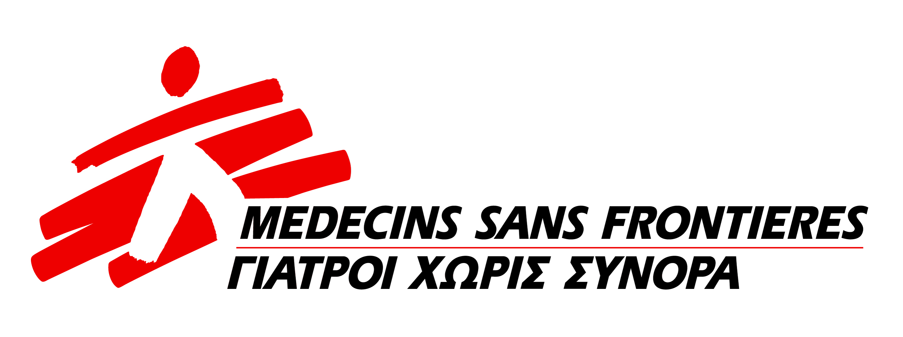
Position: Medical Doctor NCD
Project: MSF Greece Migrants
Location: Athens (mobility according to the medical needs)
Starting Date: Immediately
Duration: 6 months (possible extension)
Working Hours Flexible or/ and Full time

Context

Médecins Sans Frontières (MSF) is an international independent medical and humanitarian action-driven organization that offers assistance to populations in distress, to victims of natural or man-made disasters and to victims of armed conflict, without discrimination and irrespective of race, religion, creed or political affiliation. The MSF movement is built around 5 operational centers (OC) supported by 23 sections and offices worldwide. The MSF-Mission in Greece managed by Operational Center Geneva provides humanitarian and medical assistance to the refugee and migrants populations fleeing conflict in their home countries and following a migration route via Greece and the Balkans towards Northern Europe
Since March 2016, MSF is running a project in Greece which responds to the needs of refugees, migrants and vulnerable people from the host population in 4 locations in Greece: A Day Care Center and the squats in the City Center of Athens, daily mobile Clinics in the 3 sites of Elliniko Camp and bi-weekly mobile clinics in Thermophiles-Camp .
Main Purpose

The Chronic diseases doctor is expected to bring proficiency and expertise to the mission concerning implementing clinical guidelines for management of chronic diseases in MSF Project in Greece. The responsibilities of the chronic diseases referent doctor include follow-up of the patient, and helping with the implementation and context adaptation of an evidenced model of care for the management of patients, defining a referral system and ensuring evidenced-based, quality of care is in place.
Accountabilities
- The focus is on hypertension, type II diabetes, cardiovascular diseases, Chronic Obstructive Pulmonary Diseases, asthma, hypothyroidism and epilepsy (with basic management on chronic renal diseases).
- The Chronic diseases referent doctor will be working closely with the Medical Coordinator on coordination level and Project Medical Referents on field level to implement a model of care for the follow up of patients with chronic diseases that best fits the context and the evidence currently available.
- The Chronic diseases referent doctor will ensure the implementation of NCD field guides provide feedback on then and implementing changes in the new versions.
- The Chronic diseases referent doctor will work with the PMR and the field team to collaborate in the NCD data base providing feedback and follow up of the activity.
- The NCD referent doctor will enter the medical data in the Gecko system to be used for activity monitoring, follow up and reporting and will provide appropriate analyse of these dates.
- Identify training needs for NCDs team as the activity is extended as well as lead case discussion with the medical team for co/managed patients from the other departments.
- Ensuring that the patients with chronic diseases (particularly: Diabetes, cardio-vascular disease...) are supported, educated and followed up properly by all relevant members of the team and by external providers.
- In collaboration with the Health Promoter Supervisor, provide specific support to the newly implemented NCD activities and inform the communities of the medical support provided to patient suffering from chronical diseases.
- In collaboration with HP supervisor provides feedback from Health promotion material and support their implementation in the medical staff.
- In collaboration with the Project Medical Referent, defining a strategy for the follow up of chronic disease patients.
- In collaboration with the Project Medical Referents analyse the rationality for the lab tests, referrals to specialists and emergency to emergency care done in NCD program
- Ensure harmonisation of tools and services used in the camps and the Day Care Centre.
- In collaboration with the Project Medical Referents, analyse and report the NCD program activity through the regular medical reports in the mission (SitReps and project report).
- In collaboration with the Medical coordinator provides support to the implementation of the different Operational research initiatives in the mission.
- Ensure consultations and follow up for the patient’s male victims of sexual violence and suffering from sexual transmitted infections. (including teenagers)
- Contribute and monitor the ward pharmacy: availability of the relevant drugs and medical material
- Contribute and monitor the quality of the disinfection and sterilization process of the material and medical equipment
- Is in charge of new needs identification, in terms of drugs and medical equipment’s, in line with pathologies met in his/her medical practice
- Implement the Travel Medicine activity for patients having NCD and informing about their plan to move in Greece and abroad. Providing medical support with provision of treatment and education for people on the move.

Mission Greece specificities
- OCG opened in Feb 2016 its mission in Greece. After an assessment period, the mission became operational in May 2016, starting with mobile clinic activities in two refugees’ camps (Elliniko and Thermopiles). Since then, operational activities have increased smoothly with finally the opening of an Urban Day Care Centre in Athens in Sept 2016.
- This mission is still in its opening phase. The main challenges of the Medical Doctor in NCD position is to both maintain and provide the required support to the field operations and still 1/ build up the mission medical strategies in a such atypical MSF intervention 2/ ensure the implementation of MSF medical policies, protocols and tools 3/ develop qualitative case management approaches with appropriated referral paths.
- Last but not least, OCG works under a specific MoU signed with MSF Greece section that requires specific administrative, procurement and medical procedures and compliances.

Qualifications
Education | - Essential, degree in medicine. Specialization in Non-Communicable Disease or a degree in Public Health would be an asset.
Experience | - Essential, working experience in relevant jobs and previous humanitarian experience in MSF or other NGOs or community work involving migrants and vulnerable Greeks.
Languages | - Mission language (English) and local language (Greek) essential. Other languages would be an asset: Arab, Farsi, French.
Knowledge | - Essential computer literacy (word, excel and internet)
Competences | - Strategic Vision  - Leadership.  - Networking.  - Cultural.
Others
- Strong interest in migration programme
- Willing to work on atypical MSF programme

Post Conditions
- Annual gross salary: According to MSF Salary Policy
To apply
Please send your CV and a motivation letter in English quoting reference code “MD NCD" in the subject line of the e-mail at: msfch-athens-FinHrAssistant@geneva.msf.org
Closing date: 30/04/2017
All applications will be treated in strictest confidentiality

Only shortlisted candidates will be contacted

