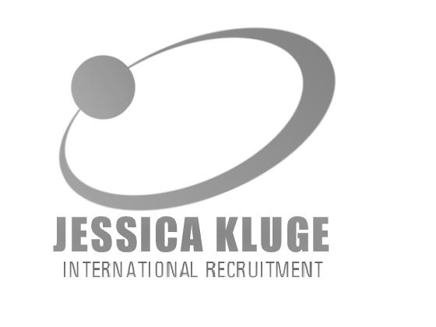
Jessica Kluge
INTERNATIONAL RECRUITMENT
Muesser Straße * 19086 * Consrade * Germany
Web: www.kluge-recruitment.com
E-Mail: application@kluge-recruitment.com

JOB DESCRIBITION (JOB NR. 707)

JOB TITEL | Specialist in Orthopedics
LOCATION | City in Saarland, Germany
INFORMATION DEPARTMENT/  HOSPITAL | The Clinic (REHA)  The Hospital Group operates in Germany and Austria rehabilitation hospitals and hotels. This health and rehabilitation center has 540 beds and specializes in the field of orthopedics and Psychosomatics / psychiatry. Integrated is a large Department of Traditional Chinese Medicine (TCM). The facility is certified.  Your department  In our health and rehab center for both inpatient treatment pursuant to § 40 SGB II and V § 15 SGB VI and prevention measures according to § 20 SGB V and outpatient retirement benefits under § 23 SGB V are performed.  Your Benefits  An interesting and varied professional work in a collegial atmosphere is offered with individual, performance-related remuneration. Furthermore, specialized training will be encouraged and financially supported.
SALARY | 54.000 € - 70.000 (Gross/Year)
REQUIREMENTS | - German Language in B2 or even better C1  - Specialist Orthopedics

If you want to apply for the above position or need more information please send an e-mail to:
application@kluge-recruitment.com
We'll get back to you as soon as possible.
You are also welcome to apply via our online form:
http://www.kluge-recruitment.com/Doctors/form.php

